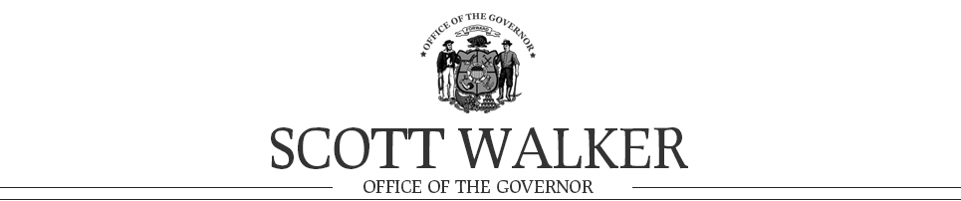
FOR IMMEDIATE RELEASE
May 2, 2014
Contact: Laurel Patrick, (608) 267-7303
Contact: Lisa Marshall, (608) 267-3773

Wisconsin Tourism Industry Continues Steady Growth In 2013
Tourism economy up 4 percent; Visits to the state topped 100 million

Madison – Travelers spending their hard-earned vacation dollars in Wisconsin remains big business for the state as tourism delivered a $17.5 billion impact to the economy last year. Tourism activity was up 4 percent or $700 million from $16.8 billion in 2012 and continues to show stable, long-term growth according to just released economic impact figures. That’s the message being presented today by Governor Scott Walker and Tourism Secretary Stephanie Klett as they kick off this year’s National Travel and Tourism Week, May 3-11, at Miller Park in Milwaukee.

“The travel and hospitality industry continues to be an important and strong performing sector for Wisconsin’s economy,” said Governor Walker. “Investing in tourism promotion and marketing at the national, state, and local level is an effective way to attract visitors and keep the economy growing.”

Key Results
The total three year growth of tourism activity is more than $2.7 billion, up from $14.8 billion in 2010, an 18 percent increase for this period, according to Tourism Economics, the research firm commissioned by the Department of Tourism. Visitor growth in 2013 was the fastest since 2010, with Wisconsin receiving 100 million visits last year, an increase of 3.5%. Other industry indicators included a strong upswing in day travelers, which helped push recreation and entertainment spending up 6.3 percent and food and beverage up by 6.2 percent. International travel, which includes overseas and Canada, totaled $700 million, up $100 million from the previous year, and accounted for 6% of all travel last year.

Tourism supports nearly 185,000 jobs and $4.6 billion in personal income. One in nearly 13 jobs in Wisconsin relies on tourism. Visitors generated $1.35 billion in state and local revenue and $1 billion in federal taxes in 2013, saving Wisconsin taxpayers nearly $590 per household. Individual county information figures are also available.

“The past three years have been outstanding for Wisconsin’s tourism industry,” said Secretary Klett. “The increased investment in tourism marketing has allowed us to expand our advertising campaigns and leverage celebrities with Wisconsin ties; bring in the nation’s top travel writers to experience our destinations; tap into international markets; and, attract lucrative sporting events, meetings and conventions.”

Marketing Translates into Travelers
According to Longwoods International, for every $1 the Department spent on its 2013 summer and fall advertising campaigns, $6 was returned to state and local governments in incremental tax revenue. In March, the Department’s 2014 TV ad campaign made pop culture history by reuniting “Airplane!” stars Kareem Abdul-Jabbar and Robert Hays with Wisconsin natives and "Airplane!" writers and directors David and Jerry Zucker and Jim Abrahams. The summer, fall and winter spots include seasonal aerial footage of Wisconsin along with new scenes filmed in the original cockpit of the movie. In addition, last year’s public relations efforts generated over $70 million in earned media and 1.5 billion impressions. In another sign of increased interest in travel to Wisconsin, visits to TravelWisconsin.com and its app totaled 4.1 million in 2013, up 25%.

This year’s summer tourism campaign launches the week of May 12 and will run in markets across Wisconsin, northern Illinois, the Twin Cities, and in eastern Iowa.

Tourism Economics is an Oxford Economics company providing analyses of the tourism sector. Longwoods International is a globally recognized leader in travel research, with over 30 years of experience with a hospitality client list, including Michigan, Ohio, Philadelphia, and Canada.

The mission of the Wisconsin Department of Tourism is to market the state as the Midwest’s premier travel destination for fun by executing industry-leading marketing programs and establishing strategic partnerships. The Department plays a significant role in generating greater economic impact and jobs for Wisconsin. The portal for traveler information can be found at www.travelwisconsin.com.

###

