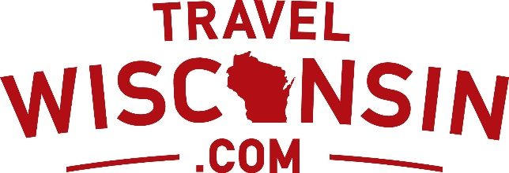

**MEDIA CONTACT:**

Craig Trost, Wisconsin Department of Tourism

608-267-3773; [ctrost@travelwisconsin.com](mailto:ctrost@travelwisconsin.com)

**TRAVEL WISCONSIN POSTPONES ANNUAL TOURISM CONFERENCE**

**MADISON (March 11, 2020) –** The Wisconsin Department of Tourism announced today the postponement of the Wisconsin Governor’s Conference on Tourism (WIGCOT), to May 26-28, 2020 at the Monona Terrace Convention Center in Madison.

WIGCOT is an annual three-day education and networking event bringing together approximately 900 representatives from around the Wisconsin Tourism industry, including innkeepers, restaurateurs, community tourism officials, tourism attraction operators, state agency officials, tourism educators and others.

The conference was previously scheduled to take place March 15-17, 2020.

“Postponing the conference was not a decision our team took lightly; our industry leaders need to be in their communities working to lead during this uncertain time and that is exactly where they ought to be,” said Sara Meaney, Tourism Secretary-designee. “We look forward to sharing results from our tourism efforts in 2019 as well as some exciting updates about our long-term planning over the next few weeks. Of course, I also look forward to our industry gathering to celebrate our shared successes at WIGCOT 2020 in May.”

Neither the CDC nor the Wisconsin Department of Health Services have advised travel restrictions in Wisconsin at this time. The postponement of the conference is not guidance for any other meetings or conventions in Wisconsin.

###

**About the Wisconsin Department of Tourism**  
The mission of the Wisconsin Department of Tourism is to market the state as a premier travel destination by executing industry-leading marketing programs and establishing strategic partnerships. The Department plays a significant role in inspiring incoming travelers to make unexpected connections through a refreshing vacation in Wisconsin. Wisconsin tourism generates a $21.6 billion economic impact and supports more than 199,000 full and part-time jobs. The portal for traveler information can be found at [www.TravelWisconsin.com](http://www.TravelWisconsin.com).